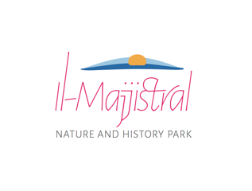
Activities Application Form to hold an activity within il-Majjistral Nature and History Park

The following activities are prohibited unless in possession of a valid permit or authorisation issued under the direction of the Park Manager

- Vehicular access to the Park, including for loading and unloading.
- The temporary construction or placement of sets on site.
- Branding (flags, posters, lights, etc.) done on site.
- The use of artificial sounds such as whistles, horns and bells.
- Activities taking place outside designated paths.
- Setting up a fire for entairtainment purposes, including fireworks, bonfires, barbecues and camp-fires.
- Camping.
- Zip-lining.
- Abseiling.
Other notes:
- Any posters or other branding material left on site is to be collected by not later than a day following the activity.
- During the birds‘ breeding season (here taken as from March to July) any authorised branding material should not be higher than one metre from ground level so as to minimise disturbance.
- The place of the activity is to be left clean and no litter is to be left on site.
- Moving, removing, or shifting any equipment used for the management of the Park, including signs, is strictly prohibited.
- Walking and cycling activities are to be done on designated foothpaths only.
- Damage to the Park and its biodiversity is strictly prohibited.
- Any activity permit issued by the Manager does not exempt the applicant from obtaining any other permit or license required by Law.
- Any conditions attached to a permit issued by the Manager are an essential part of such permit, and their breach would invalidate the said permit
- The organisers are to comply with any guidelines or instructions given on site by a Majjistral Park ranger during the event

---------------------------------------------------------------------------------------------------------------

Part I. Details of the applicant
Name of person or company |  | Name of contact person
Address
ID Card No |  | Email
Telephone |  | Mobile
VAT No
Part II. Details of the activity
1. Name of the activity
2. Dates and time of the activity, including times for preparation and dismantling
3. Location
4. Brief description of the activity
5. Is the activity
a private function |  |  |  |  | a philanthropic cause
6. Expected number of participants during the activity
7. Does the activity include the placing of equipment or construction of sets on site? |  |  |  |  |  |  |  | Yes | No
If yes, please specify.

8. Do you require any equipment or services from the Manager? |  |  |  |  |  |  |  | Yes | No
If yes, please specify.
Equipment required:

Services required:

9. Mark the area where the requested activity will take place in the attached site plan.
Part III. Signature of the applicant
Name |  |  | Designation
Date |  |  |  | Signature
Part IV. For office use only
Fee |  |  | Deposit
Conditions
Date |  |  |  |  | Official Stamp
Approved by
Signed by
Signature

Part V. Ranger Note
Have the organisation and participation in the event been satisfactory for the proper management of the Natura 2000 site? |  |  |  | Yes | No
Tick as necessary | Cooperation of participants and organisers with site ranger. |  |  | Good | Poor
 | Noise and other public disturbance levels. |  |  | Low | High
 | Compliance with other permit conditions. |  |  | Complete | Incomplete
Other Comments
Date
Ranger |  | Signature

Site Map – il-Bajja tal-Mixkuka (Golden Bay), Malta

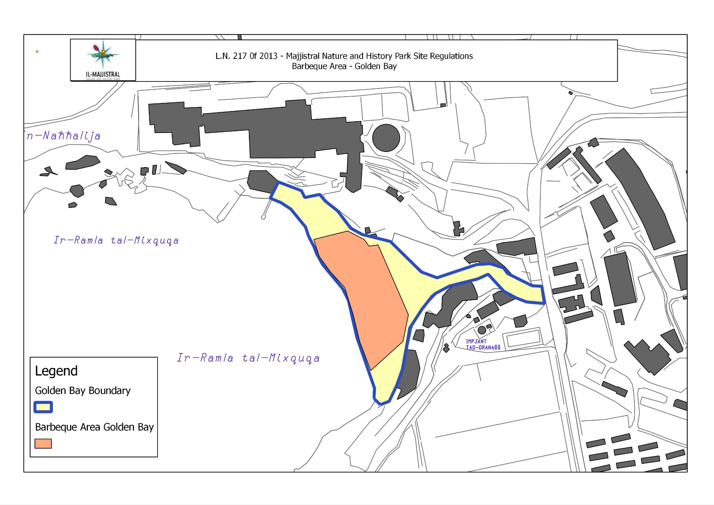

Site Map – Majjistral Nature and History Park, Malta

