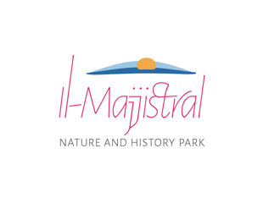
Activities Application Form to hold an activity within il-Majjistral Nature and History Park

Notes to Applicant

- Vehicular access to the beach is strictly prohibited.
- The sand dune at the back of the beach is a protected, no entry zone. A five (5) meter buffer zone shall be kept from the sand dunes, in front of the already cordoned area and the access to the sand dunes or over any natural vegetation within the site is strictly prohibited.
- Open fires are prohibited. Only gas barbecues are allowed.
- The activity is to be limited to the selected area. No activity whatsoever is to be done on vegetation including in cordoned areas.
- Sound levels are to be kept to a level that would not create a disturbance to other beach patrons situated at other parts of the Park and shall be switched off by 11pm.
- Any equipment is to be removed when the activity ends.
- All waste generated is to be disposed of by the organisers in the appropriate bins or taken.
- The use of balloons, confetti and tiki-torches are prohibited.
- Any activity permit issued by the Manager does not exempt the applicant from obtaining any other permit or license required by law.
- Any conditions attached to a permit issued by the Manager are an essential part of such permit, and their breach would invalidate the said permit.
- The organisers are to comply with any guidelines or instructions given on site by the Majjistral Park Ranger during the event.

---------------------------------------------------------------------------------------------------------------

Part I. Details of the applicant
Name of person or company |  | Name of contact person
Address
ID Card No |  | Email
Telephone |  | Mobile
VAT No
Part II. Details of the activity
1. Name of the activity
2. Dates and time of the activity, including times for preparation and dismantling
3. Location
4. Brief description of the activity
5. Is the activity
a private function |  |  |  |  | a philanthropic cause
6. Expected number of participants
7. Does the activity include the placing of equipment or construction of sets on site? |  |  |  |  |  |  |  | Yes | No
If yes, please specify.

8. Do you require any equipment or services from the Manager? |  |  |  |  |  |  |  | Yes | No
If yes, please specify.
Equipment required:

Services required:

9. Mark the area where the requested activity will take place in the attached site plan or provide a site plan.
Part III. Signature of the applicant
Name |  |  | Designation
Date |  |  |  | Signature

Site Map – il-Bajja tal-Mixkuka (Golden Bay), Malta

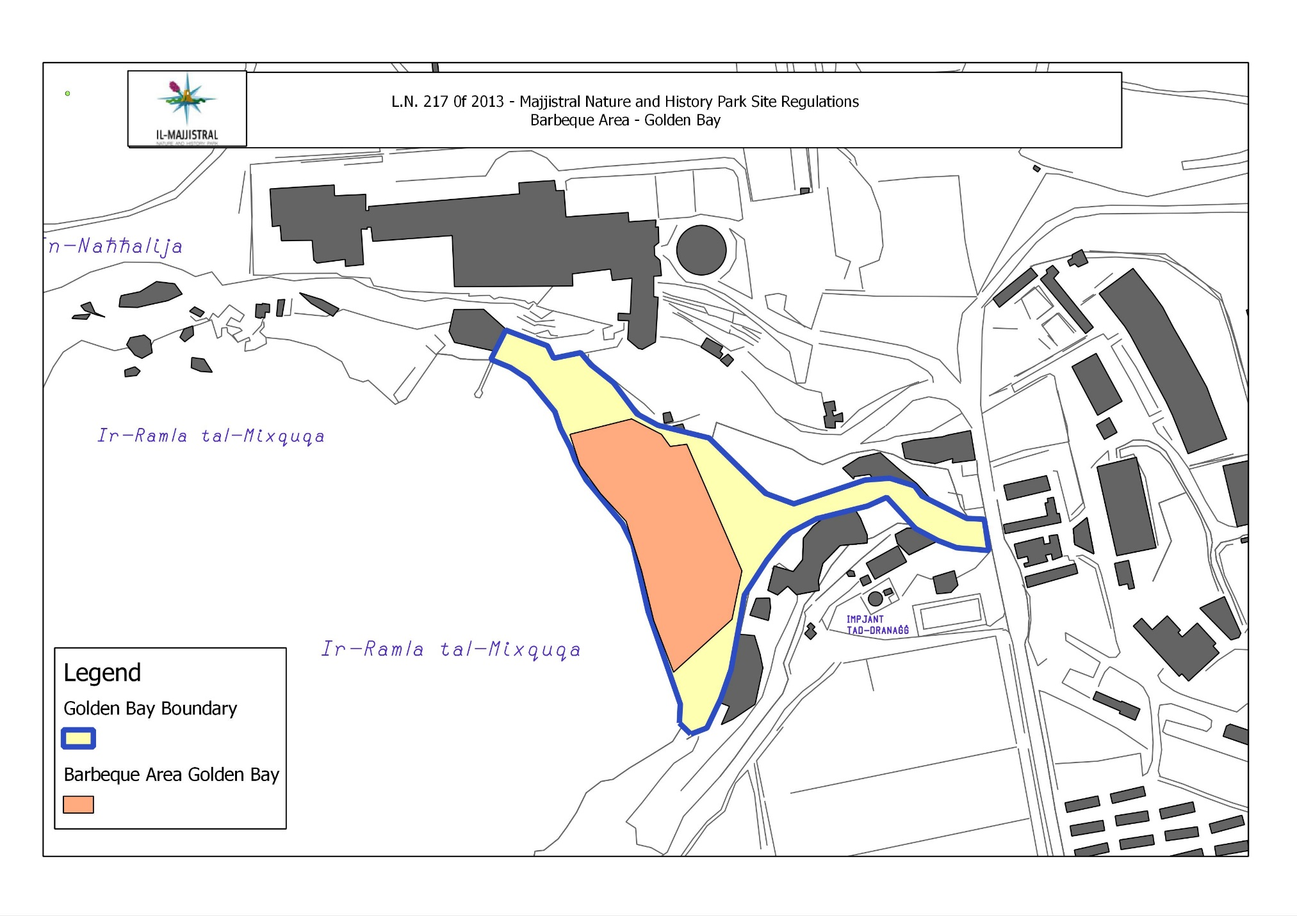

Site Map – Majjistral Nature and History Park, Malta

